Chapter 18, Solution 10.

Obtain the Fourier transforms of the signals shown in Fig. 18.35.

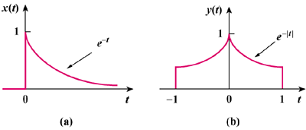

Figure 18.35
For Prob. 18.10.

Solution

(a) x(t) = e^{2t}u(t)

X(ω) = 1/(–2 + jω)

Y(ω) =

